Strategies for Developing University Innovation Ecosystems:
An Analysis, Segmentation, and Strategic Framework
Based on Somewhat Non-Intuitive and Slightly Controversial Findings

Mike Cohen
Director, Innovation Ecosystem Development
Office of Intellectual Property & Industry Research Alliances (IPIRA)
UC Berkeley

Abstract

Universities have been increasingly viewed as catalysts for regional economic vitality – especially related to innovation, entrepreneurship and startups. Accordingly, many universities have been increasingly trying to establish robust innovation ecosystems that drive local economic development (which in turn, bolster university research and education programs). This paper describes an analysis, framework and strategies for developing robust university innovation ecosystems (UIEs). The paper’s analysis reveals the following somewhat non-intuitive or slightly controversial observations that are leveraged in developing ecosystem strategies:
(1) Organizational Structure: While (not surprisingly) people talent has the most significant influence on UIE performance, the highest performing ecosystems also have a high degree of decentralization because that maximizes dynamism, resources and expertise.
(2) Organizational Leadership: While high performing tech transfer offices are important to high performance UIEs, it’s optimal for a university’s academic units (i.e. business school, engineering college, and/or applied sciences programs) to take a UIE leadership role because in comparison to tech transfer offices, academic units can more readily, (a) integrate ecosystem programs into educational curriculum thereby increasing student experiential learning opportunities; and (b) leverage relationships with their alumni thereby increasing mentor and investor network opportunities.
(3) Innovation-Drain: Universities that aren’t located in proximity to private sector technology clusters incur ecosystem innovation-drain (because practically all of their entrepreneurial graduates and spinout companies relocate out of the ecosystem), and consequently, that makes it challenging for those universities to achieve the critical-mass of human talent necessary for a robust UIE.
(4) Innovation-Importing: In contrast to the meme that most universities have readily commercializable technologies “sitting on the shelf”, the top UIEs have a greater demand for readily commercializable technologies than those universities can supply (especially technologies that address important societal problems); and therefore, the top UIEs are able to effectively import innovations from other research institutions.

1. Introduction

Across the US and other developed countries, universities have been fundamental to regional economic vitality. For example, Stanford, UC Berkeley and UC San Francisco have been playing a key role in driving the economic prosperity of the Bay Area (including Silicon Valley). Likewise, MIT, Harvard, Tufts and the Boston area’s other universities have been significantly contributing to that region’s economic vibrancy.

This awareness of the relationship between universities and economies has motivated universities (and their jurisdictional governments) to augment university programs and resources that drive the commercialization of university-developed technologies. These programs and resources encompass: applied research, entrepreneurship education, technology transfer, idea incubators, startup accelerators, new venture competitions, mentor networks, industry collaborations, and venture capital resources. These programs and resources, in aggregate, are referred to as a university innovation ecosystem (UIE).

This paper develops strategies for creating robust UIEs by, (1) analyzing several UIEs; (2) identifying correlations among top ecosystems, (3) positing how those correlations maximize ecosystem performance, and (4) describing a strategic framework for segmenting university ecosystems.

2. Analysis

In July 2015, Forbes published a ranking titled, Startup Schools: America’s Most Entrepreneurial Universities: http://www.forbes.com/sites/liyanchen/2015/07/29/americas-most-entrepreneurial-research-universities-2015/ . The author is familiar with the UIEs at dozens of campuses including many of those in the top 50 of the Forbes list. While UIEs can be characterized by many attributes, the top UIEs share two key characteristics. First, the top ecosystems have strong pools of innovative and entrepreneurial students, faculty and staff. Second, the leading ecosystems have relatively decentralized entrepreneurship-related activities, not top-down centralized control of activities. While the importance of human talent is obvious, the benefits of a decentralized UIE are not intuitive to most people—especially because decentralization has tradeoffs (such as cost inefficiencies due to overlapping programs, and confusion for people trying to leverage UIEs). Therefore, a methodical analysis was conducted of a variety of UIEs in order to assess the observations about organizational structure as well as talent.

Organization: To quantify the extent to which a particular UIE has centralized or decentralized activities, web searches of that ecosystem’s university were conducted using words such as “entrepreneurship” and “startups”. If a university’s search results reveal a plethora of autonomous programs and resources, then the university’s ecosystem is characterized as decentralized.

Talent: To quantify the extent to which a particular UIE has human talent, ratings of the ecosystem’s graduate engineering and business programs were researched. The Academic Ranking of World Universities (ARWU) was used to assess a UIE’s engineering talent: http://www.shanghairanking.com . The US News MBA ranking was used to assess a UIE’s business talent: http://grad-schools.usnews.rankingsandreviews.com/best-graduate-schools/top-business-schools/mba-rankings .
These metrics aren’t definitive determiners of UIE talent and organizational structure, but they are readily producible approximations. An analysis is summarized below of six UIEs: two private universities and four public universities – including two campuses of the University of California (UC).

It’s a striking correlation that the top three universities on the Forbes list – Stanford, MIT and UC Berkeley – are the top three universities on the ARWU ranking of engineering programs. Those three universities also were in the top seven of the US News ranking of MBA programs. To the extent that these rankings correlate to the talent of the faculty, students and staff, there is clearly a relationship between talent and UIE performance. Now, let’s consider UIE organizational structures of these top three universities.

Stanford: Searches on Stanford’s website reveal the Stanford Entrepreneurship Network (SEN): https://sen.stanford.edu/. It’s notable that the introduction on SEN’s homepage explicitly states that, “our university’s entrepreneurial activity is decentralized”. Indeed, the SEN website has a listing of over 30 entrepreneurship-related organizations affiliated with Stanford.

MIT: Searches on MIT’s website reveal over 40 entrepreneurship-related programs including 9 centers (i.e. Martin Trust Center, Deshpande Center, Legatum Center), 16 clubs, 5 competitions, and numerous forums. A web page that highlights some of MIT’s UIE is here: http://web.mit.edu/facts/entrepreneurship.html .

UC Berkeley: Searches on UC Berkeley’s (UCB) website reveal an entrepreneurship ecosystem web directory: http://entrepreneurship-ecosystem.berkeley.edu . The directory has a list of over 40 programs and resources across five categories (including programs operated by the Lawrence Berkeley National Lab that is adjacent to UCB). An infographic of the vast, decentralized Berkeley UIE is shown in Diagram 1.

Note that characterizing a UIE as decentralized doesn’t mean that there’s no coordination across the ecosystem. For example, UCB’s flagship startup accelerator, SkyDeck, is a collaboration between that university’s college of engineering, business school, and vice chancellor of research office.

Diagram 1 – UC Berkeley’s Innovation Ecosystem

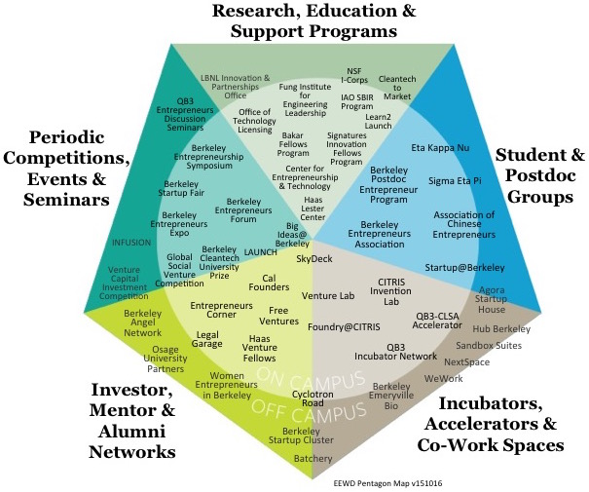
It’s not likely to be a coincidence that these top three UIEs have decentralized organizational structures. Nonetheless, let’s look at some other respected universities.

University of Texas, Austin (UTA): UTA is listed as #5 on the ARWU engineering ranking and #17 on the US News MBA ranking – indicating that the university has talented faculty, students and staff. However, UTA is listed as only #22 on the Forbes startup ranking. A search of UTA’s web site indicates that it only has about 10 entrepreneurship-related programs as listed on this web page: http://www.engr.utexas.edu/innovation .

University of Michigan, Ann Arbor (UMAA): UMAA is listed as #8 on the ARWU engineering ranking and #11 on the US News MBA ranking. Despite those high talent indicators, UMAA is listed as only #43 on the Forbes startup ranking. A search of UMAA’s website reveals Innovate Blue, http://innovateblue.umich.edu , which describes itself as, “the University of Michigan’s hub for entrepreneurship and innovation”. Innovate Blue’s “Programs and Partners” web page list 21 programs across two campuses (including loosely affiliated programs such as Innovate Detroit). An infographic of the UMAA UIE is shown in Diagram 2.

University of California, Irvine (UCI): UCI is listed in the 51-75 range of the ARWU engineering ranking, and #53 on the US News MBA ranking. UCI is not in the top 50 of the Forbes startup ranking. A search UCI’s website reveals The Cove, http://innovation.uci.edu, a centralized “entrepreneurial ecosystem under one roof”.

Diagram 2 – University of Michigan Innovation Ecosystem

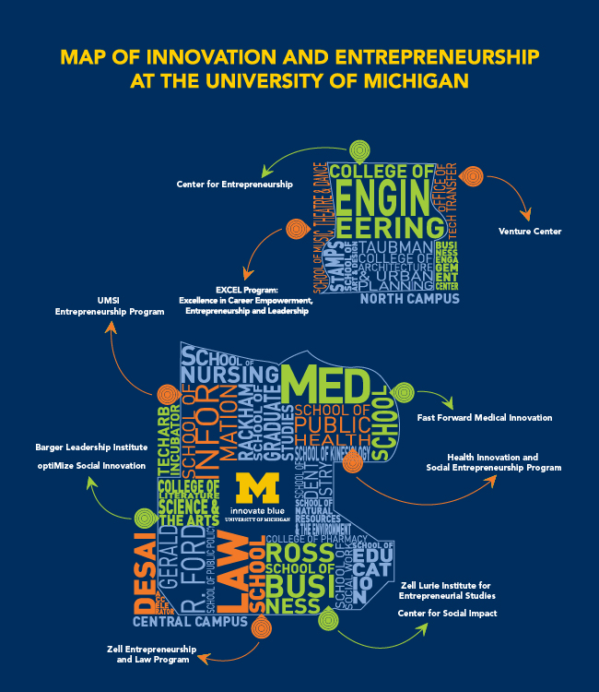

Diagram 3 shows the above six UIEs placed on a matrix with the talent and organization attributes along the horizontal and vertical axes.

Diagram 3 – UIE Matrix of Talent & Organization

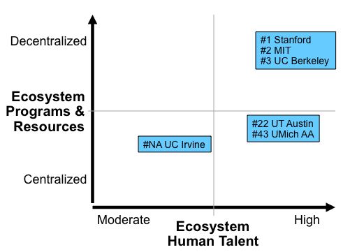

Interpretation of the above data starts with the realization that the top UIEs develop over many years – not just a few academic calendars. This fact is important in comparing, for example, the UIEs of MIT and UCI. The former has been developing over decades, while the latter is relatively young. With this multi-year process in mind, it is posited that the highest performing UIEs mature into decentralized ecosystems for the following four reasons.

1) Autonomy: Faculty and academic units at most top research universities have lots of autonomy. This is a source of academic excellence, but it also impedes imposing top-down organizational control. Accordingly, lots of UIE-related centralized administrative control is not practical at the top universities. For example, at many top universities such as UCB, the engineering and business units each have their own entrepreneurship-related academic programs, accelerators, clubs, competitions and mentor networks.

2) Dynamism: Technology and business are perpetually changing. Accordingly, high performing UIEs need to be dynamic. In other words, top UIEs have become successful through ongoing, decentralized experimentation and initiative. Those activities that succeed endure; and those that don’t pivot or shutdown. Too much top-down control can stifle this dynamism. An example of a UIE initiative that has dynamically pivoted is how the UCB business school’s competition program has evolved and rebranded itself from a business plan competition, to a startup competition, to its current format as a startup accelerator (called LAUNCH). Those changes follow the emergence of the lean startup conventional wisdom. An example of a top-down UIE initiative that failed is the East Bay Green Corridor. However, that failed program helped to spawn the successful Berkeley Startup Cluster.

3) Expertise & Guidance: Different technologies, markets and business models require different expertise and approaches for successful commercialization. For example, the commercialization expertise and approaches vary for biotech, cleantech, hardware, and software, etc. In comparison to centralized UIEs, decentralized UIEs (with lots of talent) are better at providing those varied resources. For example, in UCB’s decentralized (talent-filled) UIE, the QB3 institute provides resources that are optimized for commercializing biotech innovations; the CITRIS institute provides resources that are optimized for commercializing information technology; and the BECI institute, as well as the adjacent national lab’s Cyclotron Road program, provide resources that are optimized for commercializing cleantech innovations.

4) Private Sector: Most top-tier UIEs are located on campuses that are in close proximity to lots of innovation-related, private sector activities – such as venture capital firms, startup accelerators, and corporate R&D offices. This nearby private sector activity contributes to the campus’s innovation ecosystem. However, the university doesn’t control these private sector contributions, and accordingly they augment the decentralized nature of the UIE.

3. Leadership

The leadership of UIE development varies across universities. Typically, a university’s engineering, applied sciences and business academic programs, as well as its tech transfer office (TTO) play important roles in the ecosystem. At many top universities, the engineering and/or business schools take a lead on ecosystem development. At Harvard, for example, the business school took the lead on that university’s flagship startup accelerator, the i-Lab. (Harvard is #25 on the Forbes startup schools ranking, #25 on the ARWU engineering ranking, and #2 on the US News MBA ranking.)

Overlap: When a university has a top-tier engineering, applied science and business programs, then often those programs have UIE-related activities with partial overlap – such as idea incubators, startup accelerators, new venture competitions, and mentor networks. This contributes to the decentralized nature of top UIEs. However, these separate pillars of ecosystem activities are necessary for those top-rated programs to continue striving for excellence – especially in comparison to competitor programs at other top-tier universities. Furthermore, the UIE-related activities in the engineering and business academic units are frequently associated with professional degree programs – and those are typically income-generating (so any overlapping activities aren’t losing money for the university). At UCB, for example, the College of Engineering’s Sutardja Center for Entrepreneurship & Technology, and the Business School’s Berkeley-Haas Entrepreneurship Program (formerly the Lester Center) have partially overlapping UIE-related activities. To be clear, this overlapping situation is related to the excellence of a university’s individual academic units – and practically any universities would want this high-quality problem.

TTO: When a university’s academic units don’t take a leadership role in the development of a UIE, then the university’s TTO often steps-up to fill that void in ecosystem leadership. That situation is evident at UC Davis (UCD) with its Technology Management & Corporate Relations unit. (UCD is not in the top 50 of Forbes startup schools, #51-75 on the ARWU engineering ranking, and #48 on the US News MBA ranking.)

However, UIEs led by TTOs have disadvantages in comparison to UIEs led by academic units – for two reasons. First, academic units have ongoing relationships with successful entrepreneurial alumni, and those relationships can be leveraged in building mentor and investor networks. Second, academic units can more readily integrate ecosystem activities into their educational curriculum, and that integration increases student experiential learning opportunities. For example, UCB students with campus-based entrepreneurship experience formed UCB’s Free Ventures which helped spawn The House Fund and The House Accelerator.

The above advantages justify why TTOs at universities with top-tier engineering and/or business programs often have a smaller scope of UIE-related activities in comparison to the scope of UIE-related activities at TTOs at universities without top-tier engineering and/or business programs. For example, UCB’s TTO doesn’t have a formal venture catalyst operation because that would be redundant to the venture catalyst activities operated by UCB’s top-tier engineering and business programs. In contrast, the TTOs at UCI and UCD have formal venture catalyst operations – because the engineering and business programs at those campuses don’t have robust UIE-related activities.

Diagram 4 – Four UIE Quadrants
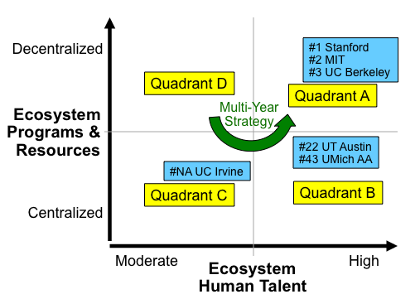

Diagram 5 – UIE Leadership Scenarios

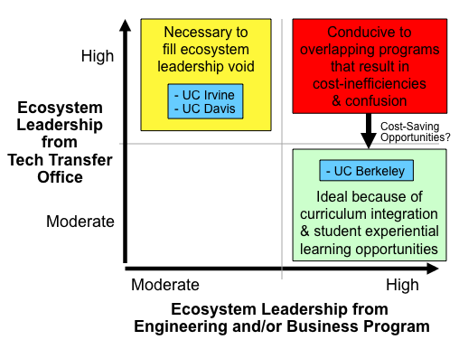
4. Strategy

Diagram 4 identifies four quadrants on the UIE matrix. Strategies for UIEs in each of the four positions are discussed below. Viewed in totality, the four strategies reveal a counter-clockwise movement around the matrix to achieve the maximized position of high talent and decentralization. That multi-step strategy is consistent with the aforementioned multi-year process of developing high performance UIEs.

Quadrant A – High Talent | High Decentralization: UIEs in this enviable position can’t be complacent because dynamism is a key attribute of high performing ecosystems. Furthermore, these types of vast, dynamic UIEs are conducive to two problems: (1) overlapping programs that result in budget and other resource utilization inefficiencies; and (2) confusion for people (especially new students and industry people) who want to take advantage of the ecosystem.

Inefficiencies: Addressing resource inefficiencies for UIEs in quadrant A can be challenging because these institutions have a culture of striving to be the highest quality, not the lowest-cost university. Given this culture of excellence, some UIEs in quadrant A are also in the upper right quadrant of Diagram 5. That combination is a red-flag for possible cost-cutting opportunities in the TTO (such that the UIE can move to the lower right quadrant in Diagram 4).

Confusion: To address the confusion issue, an important strategic imperative for UIEs in quadrant A is to provide web navigation tools and high-touch concierge services that can mitigate confusion (for all but the least resourceful newbies and outsiders). At UCB, an early attempt to provide navigation and concierge services is at: http://entrepreneurship-ecosystem.berkeley.edu . In the spirit of ecosystem dynamism, this early attempt is getting refined and supplemented by other UCB ecosystem initiatives.

Quadrant B – High Talent | High Centralization: UIEs in this position should encourage their business, engineering, and applied science academic units (not TTO) to create ecosystem programs that focus on different sectors of technologies, markets and business models. For example, undergrads, GSRs and post-docs should be encouraged to establish: (1) various UIE-related student groups (i.e. EE, CS, bioE, etc), (2) various themed poster sessions that mingle MBA students with applied science and engineering students, as well as (3) various idea, technology and startup competitions. Likewise, departments should be encouraged to establish various lab-to-market courses (as exemplified by UCB’s Cleantech to Market course), alumni mentor networks, idea incubators, startup accelerators, and maker spaces.

Innovation-Importing and the Supply-Demand of Readily Commercializable Technologies: Large universities in high-talent A and B quadrants typically have many students, independent entrepreneurs, early stage investors, and leading-edge companies searching the campus for technologies to commercialize. However, only a small percentage of university research leads to readily commercializable technologies (RCTs) because for most innovations: (1) the technology is unproven, and/or (2) the markets are too nascent for viable business models. Consequently, the demand for RCTs in a robust UIE outstrips the supply of RCTs from the university (especially for RCTs that solve important societal problems as opposed to just getting people to click more ads and buy more stuff). This situation dispels the myth that many universities have RCTs “sitting on the shelf” (sometimes attributed to risk-averse venture capital and/or onerous TTO licensing).

Universities in quadrant A and B with this RCT supply-demand imbalance should consider the following: (1) putting more resources into applied and proof-concept research as well as lab-to-market courses (that help lab teams orient their research toward RCTs); and (2) reaching-out to research institutions that aren’t integrated with universities – for example in the San Francisco Bay Area: The Buck Institute, Children’s Hospital Oakland Research Institute, Lawrence Livermore National Lab, and SRI International.

Quadrant C – Moderate Talent | High Centralization: UIEs in this position should try to attract and retain more entrepreneurial faculty, students and staff. They can pursue this by directing admissions offices to accept more entrepreneurial students. These universities can also leverage their centralized ecosystem activities to create flagship programs that can help attract and retain innovative and entrepreneurial students, faculty and staff. The Cove at UCI exemplifies this type of flagship effort. If a UIE (such as UCI) in quadrant C can move to quadrant B, then the UIE is ready to gradually decentralize in quadrant A.

Quadrant D – Moderate Talent | High Decentralization: UIEs in this position generally have weak ecosystems. Consequently, their best strategy is to coalesce their decentralized activities into a centralized and augmented ecosystem under a flagship program. The flagship program can then help attract and retain innovative and entrepreneurial students, faculty and staff. Under this approach the UIE tries to move counter-clockwise from quadrant D, to C, then B, and finally A. These UIEs could also be improved by directing their admissions offices to accept more entrepreneurial students.

Ecosystem Innovation-Drain: Universities in quadrant C or D (moderate talent) that aren’t located in proximity to a private sector technology cluster could find it challenging to achieve the critical-mass of talent necessary for a robust UIE. The reason is that these universities are annually incurring massive ecosystem innovation-drain because practically all of their entrepreneurial graduates and spinout companies move to a technology cluster (far from the university). Moreover, many of these departing students exit with know-how for commercializing technologies developed at the university.

Ecosystem innovation-drain occurs at five Ivy League universities on the Forbes startup schools ranking: Brown (#7), Princeton (#8), Dartmouth (#9), Yale (#11), and Penn (#39). This is a long-term strategic problem for those universities. For years, this innovation-drain was also occurring at UCB because many of its entrepreneurial graduates and spinout companies were locating about an hour south in the heart of Silicon Valley. However, in the past half decade, an increasing number of these students and startups are locating in the Berkeley Startup Cluster (adjacent to the campus), or only a short BART ride away in San Francisco and Oakland. That trend correlates with rapid growth of UCB’s innovation ecosystem.

Universities that have massive innovation-drain and can’t develop a local technology cluster (because the intrinsic attributes of the campus location aren’t conducive to tech clusters), should consider opening a branch campus in a location that is already a tech cluster. This branching strategy is discussed in this paper: The Strategic Value of a University’s Hyper-Local Innovation Ecosystem: Grow, Branch or Envy . This branching is exemplified by the following: Ithaca-based Cornell’s (#4 on the Forbes ranking) new $350 million graduate engineering campus in New York City; Pittsburg-based CMU’s (#31 on the Forbes ranking) growing campus in Mountain View (Silicon Valley); and Philadelphia-based Penn’s impressive campus for its Wharton Business School in San Francisco.

Conclusion

Robust university innovation ecosystems are highly desirable because they drive regional economic vitality – and that vitality in turn bolsters a university’s education and research mission. Four attributes that drive ecosystem performance are, (1) high levels of faculty, student and staff entrepreneurship-related talent; (2) decentralized, dynamic and diversified entrepreneurship-related programs, (3) local, private sector technology clusters that help keep entrepreneurial graduates and spin-out companies in a university’s ecosystem, thereby contributing to a critical-mass of human talent in the ecosystem, and (4) importing of innovations from other research institutions in order to augment the supply of (and meet the high demand for) readily commercializable technologies. These realizations can help universities with their ecosystem development strategies.

About the author: Mike Alvarez Cohen is the Director of Innovation Ecosystem Development in UC Berkeley’s Intellectual Property & Industry Research Alliances (IPIRA) office. To learn more about Mike and his other innovation ecosystem-related work, go to http://ipira.berkeley.edu/bio-michael-cohen-uc-berkeley . Mike would like to thank the contributions and support of Carol Mimura, the Associate Vice Chancellor for IPIRA; and also Marc Oettinger in IPIRA’s Office of Technology Licensing.

In March 2016, a 19-year veteran of Stanford’s Office of Technology Licensing characterized Stanford’s innovation ecosystem as, “organized chaos”.
In March 2016, a VP for Intel Labs commented, “my visit to MIT really confirmed your classification of them as a very decentralized UIE. They have separate entrepreneurial programs for each and every department of the engineering school; lots of accelerators, incubators and VCs.”
UC Berkeley’s tech transfer office (IPIRA) doesn’t have a group or even a staff person dedicated to venture catalyst activities, however it has staff (particularly the author of this paper) who integrate into their core responsibilities full-stack UIE development (which includes commercializing technology via mature corporations as well as via startups).

