The Strategic Value of a University’s Hyper-Local Innovation Ecosystem: Grow, Branch or Envy
By Mike Alvarez Cohen, MBA

Abstract:
A university’s hyper-local innovation ecosystem (Hy-LIE) not only helps drive the economic vitality of the university’s region, it is also a strategic asset to the university itself – especially its science, technology, engineering and math as well as business (STEM-B) programs. Accordingly, top-tier universities with robust Hy-LIEs are beginning to leverage this competitive asset to establish themselves in a new elite tier of universities. Correspondingly, those top-tier universities with weak Hy-LIEs that don’t address this disadvantage will be increasingly in the unenviable position of having to downplay Hy-LIEs when competing to attract and retain top STEM-B faculty and students. Already, many top-tier universities with weak Hy-LIEs are addressing their disadvantage by either: (1) growing their own robust Hy-LIE; and/or (2) branching-out with a sister campus in the robust Hy-LIE of another region. The emerging importance of a university’s Hy-LIE will lead to several trends including many research universities having: (1) campuses located in several leading US and international Hy-LIEs, (2) campus startup accelerators, (3) economic development collaborations with their local governments, (4) an employee responsible for local innovation ecosystem development, and (5) Hy-LIE characterization as a new metric by which to evaluate and rank university excellence.

Key Words:
Universities; Startups; Accelerators; Incubators; Research Parks; Entrepreneurship; Innovation Ecosystems; Tech Transfer; Commercializing Technology; Venture Capital;

Introduction

It is widely accepted among government policy and higher education leaders that universities can drive regional economic vitality (Lester, 2005). But conversely, can certain types of regional economic vitality drive university competitiveness and prestige? This article asserts that the answer is “yes”; and accordingly, a new strategic asset is emerging for universities – especially their science, technology, engineering and math as well as business (STEM-B) programs. This strategic asset is a university’s hyper-local innovation ecosystem (Hy-LIE). A university’s Hy-LIE is its readily accessible community of startup and mature companies along with entrepreneurs, mentors and early stage investors – that are in the information technology, biotechnology or other applied science sectors.

Top-tier university STEM-B programs with Hy-LIEs that have a critical mass of activity have begun to leverage this competitive asset to establish themselves in a new elite tier of universities. Consequently, those top-tier universities with weak Hy-LIEs that fail to address this disadvantage will be increasingly in the unenviable position of having to downplay Hy-LIEs when competing to attract and retain top STEM-B faculty and students. Already, many top-tier universities with weak Hy-LIEs are addressing their disadvantage by either: (1) growing their own robust Hy-LIE; and/or (2) branching-out with a sister campus in the robust Hy-LIE of another region.

To explore this trend, this article starts by clarifying the definition of a university’s Hy-LIE, and follows with an explanation of how a university’s Hy-LIE can have a strategic impact on its STEM-B programs. The article then segments universities into four groups, and observes strategies that universities are employing to grow their own Hy-LIEs, as well as examples of universities that are branching-out with second campuses in world-class Hy-LIEs. The article concludes with predictions of how the emerging importance of Hy-LIEs will influence universities.

Hy-LIE Definition

A university’s innovation ecosystem envelops its own campus people, organizations, programs and resources as well as those that are independent of the university – yet readily accessible to the campus. This article defines the latter as a university’s Hy-LIE. A university’s Hy-LIEs is measured by the extent of its readily accessible cluster of the following entities that are in the information technology, biotechnology or other applied science sectors:
- Startup, midsize and large companies – including R&D labs of diversified companies;
- Entrepreneurs – especially experienced, serial entrepreneurs;
- Early stage investors – including individual angels, angel investor groups, venture capital firms and corporate investment divisions;
- Startup incubators and accelerators, along with related mentor networks comprised of successful industry veterans.

A university’s Hy-LIE is not simply defined by close proximity to the campus, but is also characterized by accessibility to the campus (Figure 1). Accessibility includes the extent to which the following are viable: (1) walking and biking (often determined by climate and topology as well as distance), (2) mass transit – especially free university shuttles, and (3) driving (often determined by traffic as well as parking).

In addition to gradations of accessibility to its campus, a university’s Hy-LIEs can have a variety of distinguishing characteristics such as the quantity, quality, density and composition of entities. For example, some Hy-LIEs have a high percentage of information technology companies (UT Austin), and others have a preponderance of biotech companies (UC San Diego-Scripps); while some are dominated by startups (UC Berkeley-Lawrence Berkeley National Lab) and others have a majority of mature companies (Duke-UNC).

Figure 1: Hy-LIE Continuum

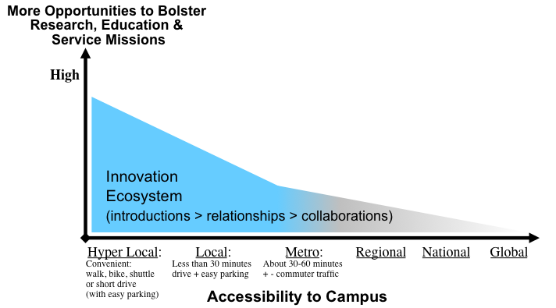

Hy-LIE Value to a University’s STEM-B Programs

A university that has helped spawn a robust Hy-LIE can be credited with helping to drive its regional economic vitality – and accordingly, the conventional mindset is that the beneficiary of a university with a robust Hy-LIEs is that university’s regional community.

However, a university’s Hy-LIE can also result in many benefits that accrue to the university itself – particularly its STEM-B programs. These benefits include additional opportunities for:
(1) Experiential learning projects for students, and case studies for faculty;
(2) Careers, internships, and summer jobs for students;
(3) Advisory, board, consulting and startup co-founder roles for faculty;
(4) Campus-based visiting industry fellows and entrepreneurs-in-residence;
(5) Relationship-building with successful alumni (that can lead to more philanthropy);
(6) Corporate sponsored university research – including collaborations with startup companies via federally funded STTR and SBIR programs; as well as
(7) Financial support – if a university takes stock equity positions in spinouts that it fosters via startup accelerators and other resources.
In addition to those seven straightforward benefits, a robust Hy-LIE can also provide the following three subtle but important benefits to its university.

Commercialization of University Technologies: The activities that facilitate the commercialization of university innovations can be divided into two categories (Figure 2): (a) activities that a university’s administration systematically pursues such as patenting, marketing and licensing intellectual property; and (b) activities that a university’s Hy-LIE organically provides such as product ideation, and the vetting, mentoring, staffing and funding of startups. The systematic efforts have an asymptotic impact because ultimately, a university can’t force a technology to be successfully commercialized. However, the organic efforts have an exponential impact in that the stronger the Hy-LIE, the more it attracts and retains resources – creating a super-critical mass effect on ideation, vetting, mentoring, staffing and funding.

Competition for Top Students and Faculty: If a top-tier university has a robust Hy-LIE, then that differentiator can be one of several competitive assets that the university leverages in competing to attract and retain top faculty and students. To understand why, imagine the atmosphere at a university with prestigious STEM-B programs but a weak Hy-LIE – causing its most ambitious students to look forward to relocating to the robust Hy-LIEs associated with peer universities. Overtime, that migration of ambitious alumni is an advantage for universities with robust Hy-LIEs.

Total Mission Integration: Finally, when a university expands its activities beyond those of catalyzing and accelerating the commercialization of innovations developed by its researchers, to also localizing that commercialization, then many of that university’s corresponding programs can holistically integrate the education, research and service missions of the university (Figure 3). The University of Utah refers to this admirable environment as “total mission integration”.

Figure 2: Systematic vs Hy-LIE Impact on Commercializing University Technology

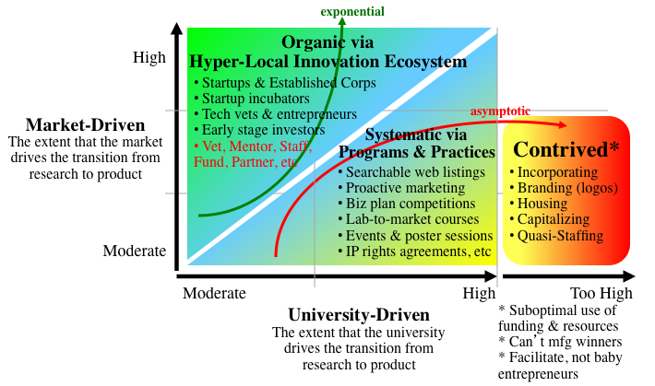

Figure 3: Total Mission Integration

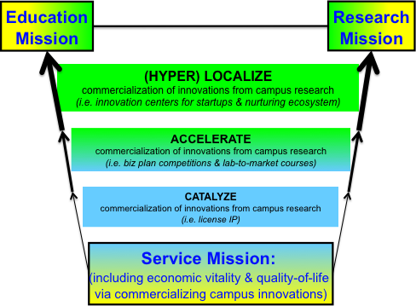

University Segmentation

To understand how a university’s Hy-LIE influences its competitiveness, universities can be analyzed along two dimensions: the quality of their STEM-B programs, and the status of their Hy-LIEs. From this analysis, universities can be divided into four segments: cultivate, catapult, can’t compete, and call-to-action (Figure 4).

Cultivate: The cultivate segment is comprised of universities that have top rated STEM-B programs and also have critical mass Hy-LIEs. This is an elite class of universities that includes Stanford in Silicon Valley, MIT and Harvard in Cambridge, and UC San Francisco in Mission Bay. Tsinghua in Beijing is also nearing this elite class. The world-class Hy-LIEs of these universities are a competitive advantage that these universities should continue to cultivate by growing Hy-LIE relationships to their campuses.

Catapult: The catapult segment is comprised of universities that are located in critical mass Hy-LIEs, but don’t currently have top rated STEM-B programs. Universities in this group include, Santa Clara University (Silicon Valley), University of San Francisco, New York University, and Boston University. Leveraging their Hy-LIE to improve the competitiveness and reputation of their STEM-B programs has great potential. This opportunity is the topic for a future article.

Can’t Compete: The can’t-compete segment is comprised of universities that don’t have top ranked STEM-B programs or robust Hy-LIEs. Accordingly, they typically focus on education market segments that don’t compete with the prestigious STEM-B programs. Universities in this group include many state universities and also liberal arts-focused colleges such as Williams, Amherst and Swarthmore.

Call-to-Action: The call-to-action segment is comprised of universities with top rated STEM-B programs but weak Hy-LIEs. Universities in this group include Cornell, Princeton, Yale and Dartmouth. In comparison to peer universities in the cultivate segment, the weak Hy-LIEs of these call-to-action universities is a competitive disadvantage. Consequently, these universities should address this situation; otherwise, this will become a disadvantage when competing to attract and retain top STEM-B faculty and students.
The remainder of this article focuses on this call-to-action segment.

Figure 4: STEM-B vs Hy-LIE Segmentation

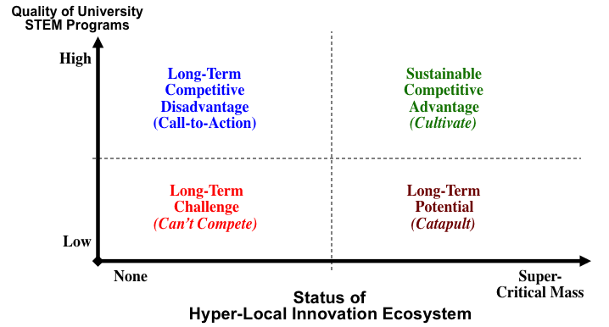

Call-to-Action: Grow, Branch or Envy

The universities in the call-to-action segment each have distinctive campus layouts and are situated in locations with unique attributes – as exemplified by Cornell in Ithaca NY, Princeton in Princeton NJ, Yale in New Haven CT, and Dartmouth in Hanover NH. Accordingly, generic action plans to address weak Hy-LIEs can’t be applied across this group of universities. However, within this group, two common approaches have emerged: (1) grow their own Hy-LIE to a critical mass of activity, and/or (2) branch-out by establishing a sister campus in the robust Hy-LIE of another region.

Determining how to grow a Hy-LIE or establish a sister campus varies depending on a university’s circumstances. For example, publically funded state universities that have highly ranked STEM-B programs but weak Hy-LIEs (i.e. University of Michigan, University of Wisconsin, and University of Illinois) can’t address this weakness by branching-out with a sister campus in the robust Hy-LIE of another state (i.e. California) – as that would be inconsistent with their state mandate. Despite these variances, common practices are emerging as described below.

The Grow Approach

For years, universities have pursued activities to help catalyze and accelerate the commercialization of technologies developed on their campuses. These activities include patenting and licensing intellectual property, establishing lab-to-market programs, and running business plan competitions. Recently, many of these universities have also developed strategies to localize their technology commercialization. Common strategies include establishing startup accelerators and technology office parks, as well as collaborations with local government and the private sector. Each of these strategies is highlighted below.

Startup Accelerators: A university startup accelerator provides nascent companies with entrepreneurship training as well as mentoring and funding networks along with free or inexpensive office space, and sometimes equipment (i.e. wet labs for biotech startups). There are a large and growing number of startup accelerators. Therefore, in order to distinguish their value propositions, many university startup accelerators are deeply integrated into their campus’s research, education and service programs (Figure 5). This integration necessitates that the accelerator is located within the Hy-LIE of the campus.

In addition to helping startups progress, these university startup accelerators can grow their Hy-LIE because as a startup expands to a certain number of employees (some estimate 10-15 employees) and establishes business relationships in its community, then those employees and business relationships make the growing company less incline to relocate to a different region.

Examples of university startup accelerators include Georgia Tech’s 30 year-old Advanced Technology Development Center, Yale’s CTech@Science Park, University of Utah’s accelerator, the 1-year old University of Michigan Venture Accelerator, Stanford’s student-run StartX, as well as the recently launched University of Washington’s C4C. UC Berkeley’s Skydeck is an example of an information technology accelerator that is largely funded by its university, and Berkeley’s wet-lab incubator – the QB3 East Bay Innovation Center, is an example of a biotech accelerator this is privately funded (by Wareham Development Inc).

Figure 5: University Startup Accelerators Versus Other Accelerators

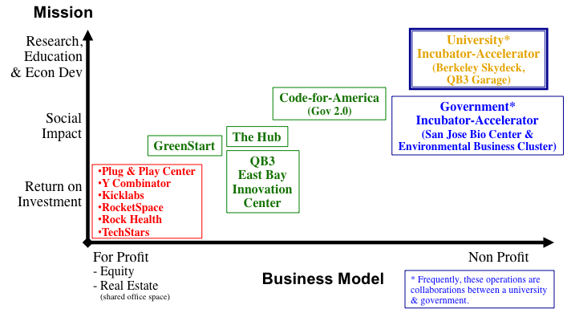

Technology Office Parks: Some universities use their real estate resources and financing capabilities to establish technology office parks in the vicinity of their campuses. These parks attract large and midsize technology and applied sciences companies to a university’s Hy-LIEs. Recently, many of office parks have been configured to also include office space that is conducive to startups.

Examples of university office parks include, the University Technology Park at Illinois Institute of Technology, University of Wisconsin-Madison Research Park, Purdue Research Park, and Stanford’s research park – founded back in the 1950’s.

Government & Private Sector Collaborations: Many universities have teamed-up with their local government and private sector to establish Hy-LIE development initiatives. Indeed, many office parks and startup accelerators have resulted from these collaborations. For example, the biotech incubator in West Berkeley (the QB3 East Bay Innovation Center) was co-founded by a collaboration between UC Berkeley, UC San Francisco, the Lawrence Berkeley National Lab, the City of Berkeley government, and the Wareham Development – a for-profit, office building developer and operator.

The San Diego-based CONNECT organization is a long-time, successful example of a Hy-LIE development collaboration between UC San Diego along with its local private sector and government. More recently, the East Bay Green Corridor and the Berkeley Startup Cluster are examples of Hy-LIE initiatives between UC Berkeley, the Lawrence Berkeley National Lab, and local governments.

The Branch Approach
Over the past decade, an increasing number of universities have established sister campuses in world-class Hy-LIEs – often, to offset the inherently weak Hy-LIEs of their home campus locations. The most common location for these sister campuses is Silicon Valley, however Beijing is also emerging as a popular destination of a sister campus.
Three examples of this branch-out approach are highlighted below.

Cornell Branches-out to NYC: Perhaps the most aggressive example of a university with top STEM-B programs that is responding to its weak Hy-LIE is Cornell. Its location in Ithaca NY is not amenable to growing a critical mass Hy-LIE. Therefore, in 2011 when the competition arose to establish an engineering campus in New York City, Cornell responded with a $350 million commitment and a partnership with Israel’s Technion University. New York City has a robust Hy-LIE, especially in the software and internet sector. The addition of Cornell and Technion along with Columbia will solidify the Big Apple as a world-class Hy-LIE.

Wharton Branches-out to San Francisco: University of Pennsylvania’s Wharton School of Business is a highly rated MBA program; however, while its Philadelphia location is a major metropolitan area, it doesn’t have a critical mass Hy-LIE, and it would be challenging to grow a critical mass there. In 2000, a Vice Dean at Wharton stated, “the West Coast is attractive to us because we see more and more students who come here who are interested in going there”. He added that, more of the School’s faculty members are also advising and studying companies in California, and more alumni are there. In 2000, Wharton established a campus in San Francisco, and ten years later, the MBA program increased its presence by moving into an expanded, flagship campus in San Francisco. http://www.nytimes.com/2000/12/13/business/wharton-school-to-start-program-in-san-francisco.html

Carnegie-Mellon Branches-out to Silicon Valley: CMU has highly rated engineering programs, and while its Pittsburg location has experienced a renaissance, it doesn’t have a critical mass Hy-LIE, and it would be challenging to grow a critical mass there. In 2002, CMU’s computer science department established a presence at NASA Ames Research Center in the heart of Silicon Valley. Six years later, the University’s College of Engineering expanded the satellite campus’s resources and its connection across CMU.

Predictions

It will become conventional wisdom that robust Hy-LIEs are a competitive asset for universities – particularly their STEM-B programs. This will result in the following trends.

Multi-Regional & Multi-National Universities: The proliferation of universities branching-out with sister campuses will result in many highly ranked universities having a campus presence in one of globe’s top Hy-LIEs such as Silicon Valley-San Francisco, New York City, and perhaps Beijing. Eventually, many prestigious STEM-B programs will have a campus presence in several Hy-LIEs. As a result, many leading US universities will evolve into multi-regional and multinational institutions – just as in the last century, most leading US companies evolved into multinational corporations.

Ubiquitous University Accelerators: In addition to multiple campuses, all highly rated STEM-B programs will have a startup accelerator. The best of these accelerators will be jointly managed by their university’s STEM-B programs. Eventually, university accelerators will be as common on college campuses as libraries, student centers, and sports stadiums.

Hy-LIE Development Collaborations: All highly ranked STEM-B programs will collaborate with their local government and private sector on Hy-LIE development initiatives. Also, in universities with STEM and MBA programs, those programs will collaborate on Hy-LIE development.

Director of Innovation Ecosystem Development: These Hy-LIE trends will lead to a new position at prestigious universities – Director of Local Innovation Ecosystem Development. This position’s responsibilities will include, (1) working with the local private sector and government to grow their Hy-LIE, (2) leveraging the university’s research to drive their Hy-LIE, and conversely (3) ensuring that their Hy-LIE bolsters the university’s research enterprise and education programs. This job could also encompass managing the university’s startup accelerator.

New Metric: Ultimately, Hy-LIEs will become a metric that will be included in the ranking of universities, and accordingly a subject for academic research and professional expertise.

Citations:
Lester, R. (2005). Universities, innovation, and the Competitiveness of Local Economies, Massachusetts Institute of Technology, Cambridge, Retrieved from http://web.mit.edu/ipc/publications/pdf/05-010.pdf

Acknowledgements:
The author would like to thank Peter S. Fiske, Ph.D. for his edits and contributions to this paper.

Author:
Mike Alvarez Cohen, is the Director of Local Innovation Ecosystem Development at UC Berkeley’s Office of Intellectual Property & Industry Research Alliances. For more information about Mike, go to:
http://ipira.berkeley.edu/bio-michael-cohen-uc-berkeley

